PIZZA SALES SQL QUERIES

1. KPI’s
2. Total Revenue:

SELECT SUM(total_price) AS Total_revenue FROM pizza_sales;

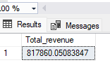

1. Average Order Value:

SELECT SUM(total_price) / COUNT(DISTINCT order_id) AS Average_order_value FROM pizza_sales;

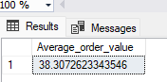

1. Total pizza sold:

SELECT SUM(quantity) AS Total_pizza_sold FROM pizza_sales;

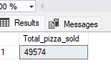

1. Total orders:

SELECT COUNT(DISTINCT order_id) AS Total_orders FROM pizza_sales;

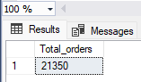

1. Average pizza per order:

SELECT SUM(quantity) / COUNT(DISTINCT order_id) AS Average_pizza_per_order FROM pizza_sales;

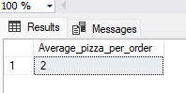

1. CHART’s
2. Daily and hourly trend from total orders:

--Daily Trends

SELECT DATENAME(DW, order_date) AS order_day, COUNT(DISTINCT order_id) AS total_order

FROM pizza_sales

GROUP BY DATENAME(DW, order_date)

--Hourly Trend

SELECT DATEPART(HOUR, order_time) AS order_hours, COUNT(DISTINCT order_id) AS total_order

FROM pizza_sales

GROUP BY DATEPART(HOUR, order_time)

ORDER BY DATEPART(HOUR, order_time)

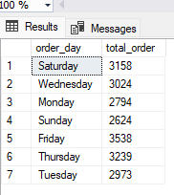 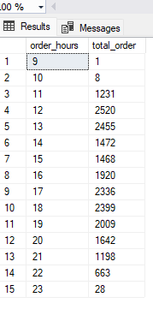

1. Percentage of sales by pizza category:

SELECT pizza_category, sum(total_price) *100 / (SELECT SUM(total_price) from pizza_sales) AS total_sales

from pizza_sales

group by pizza_category

